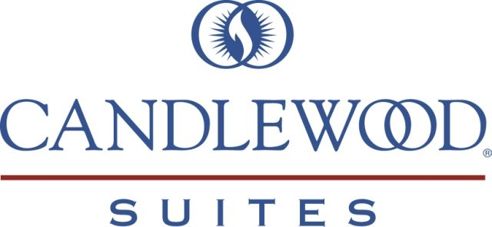

Candlewood Suites is proud to provide accommodations for the NLU Swim Team from Friday, May 30th to Sunday, June 1st 2014! For this special occasion we have provided a room block at a discounted rate of $58/night. To take advantage of this great offer, please read the guidelines below:

* To make your reservation, please call the front desk at (316) 634-6070. Be sure to mention you are with the NLU Swim Team group block. All reservations must be made by the reservation deadline of May 15th, 2014. Credit Card required for check-in.

Additional Amenities: (all included in rate)
*Rooms have 1 queen size bed*
Fully equipped kitchen in all rooms (full size refrigerator, 2 burner stovetop, microwave, dishwasher, coffee maker)
Kitchen includes all pots, pans, cooking utensils as well as tableware
Free laundry facilities
Work station w/2 phone lines & data port,
Free high speed internet (wired and wireless)
Free local calls
Free DVD/VHS/CD check out at Front Desk
On-site mini convenience store with 24 hour access
On-site fitness center
All utilities
All linens included
Weekly housekeeping

It is my sincere hope that you will allow Candlewood Suites the opportunity to provide you with the service, comfort and convenience needed to get the job done – at the lowest possible rates. If you have any questions or would like to book your reservation today, please do not hesitate to contact me personally at (316) 634-6070.
We look forward to exceeding your expectations!
Sincerely,
Jesse Socha

Director of Sales
O: (316) 634-6070
C: (316) 207-7777
Jesse.socha@ihg.com



